**Topic: Applications of rates, ratios and percentage**

Time: 45 mins Marks: /45 marks

**Calculator Assumed**



**Question One: [2, 2, 3, 3, 5, 3: 18 marks]**

a) If sliced, cold, turkey breast costs $18.25 per kilo, how much would 600 grams cost?

b) Glenda is haggling with a sales assistant over a pair of shoes she wants to buy. They are marked at $99.95 and the sales assistant says she can offer Glenda 18% off the ticketed price. How much will they cost Glenda after the reduction?

c) If Clarence bought a jumper for $23 on a 40% off sale, what was the price before it was discounted?

d) If GST was already added onto an account from a plumber and the account came to $57.80, how much was the job before the GST was added on?

e) A shoe store is having a sale. The sale is called ‘Choose your discount’. Customers have a choice of *Second Pair Half Price* (where the cheaper of the two pairs is half price) or *25% Off the Total Price*.

i) Lisa has chosen a pair of boots for $119 and a pair of flats for $89. How much would she pay in total if she chose the *Second Pair Half Price* discount?

ii) Is *Second Pair Half Price* the best choice of discount? Justify your answer.

f) Emily purchases the following items.

Sun Hat

$49.95

Take 15% OFF!

Sunglasses

Price: $99.95

TAKE 25% OFF!

What is the total cost of Emily’s purchases after the discounts are applied?

**Question Two: [3, 2, 6, 3, 3: 17 marks]**

The following are excerpts of a water corporation account.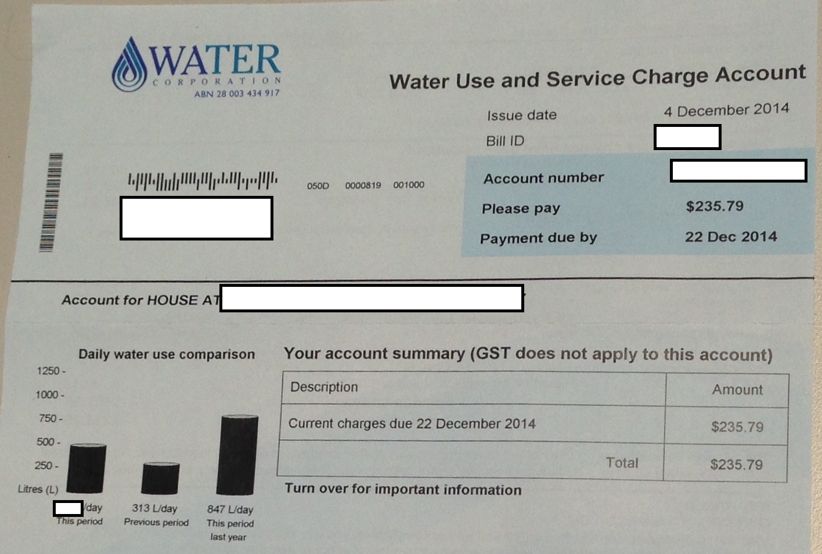

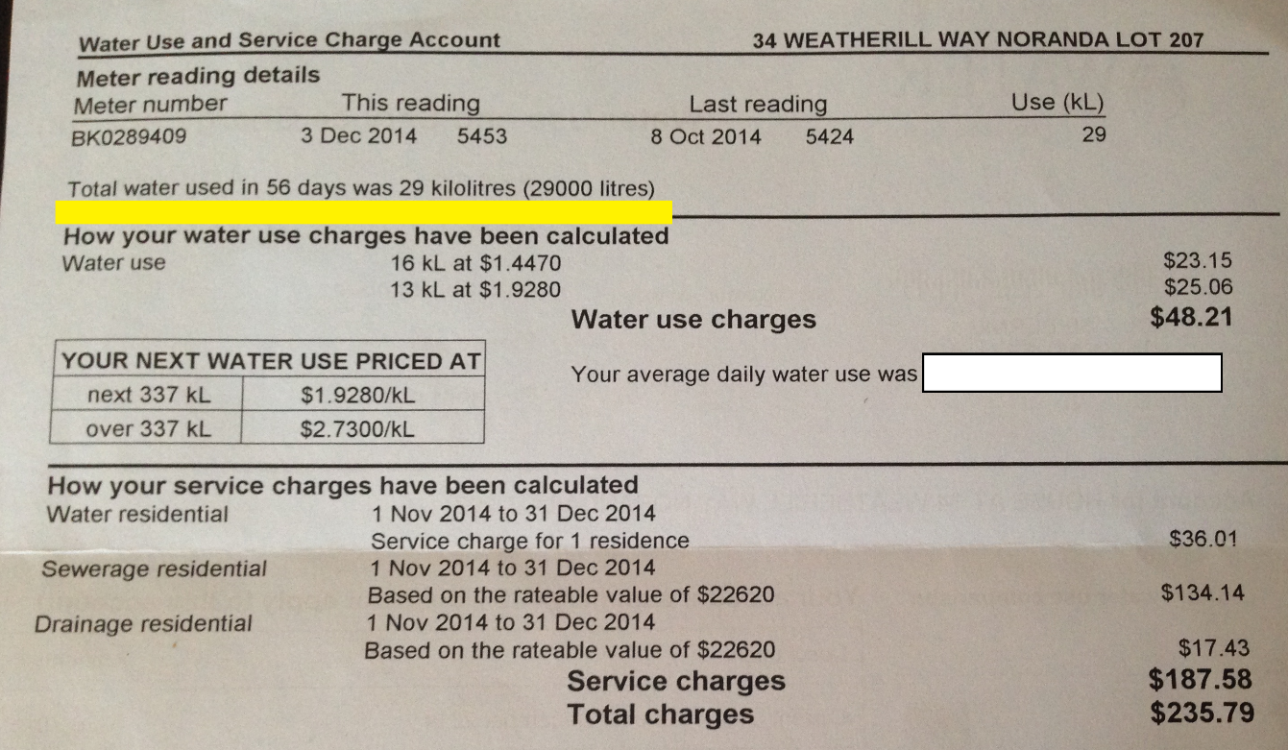

Use the information on the bill provided to answer the questions on the following page.

a) On the second part of the bill, the water use charges of $48.21 are stated. Calculate

i) the average number of litres used per day.

ii) the average cost per day.

b) What percentage of the total bill are the water use charges?

c) Assuming that the same period last year was for the same amount of days and that the water use charges were calculated in the same way,

i) Calculate the total number of litres of water used in this period last year.

ii) Calculate the water use charges for the water used in this period last year, rounded to the nearest kL.

d) Calculate the percentage increase in water use from this period compared to last period.

Interest is charged on overdue amounts @ 12.38% p.a.

e) If this bill is paid 20 days late, calculate the overdue fees.

**Question Three: [3, 3: 6 marks]**

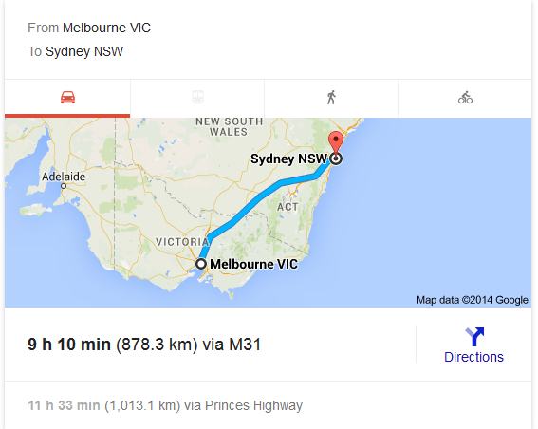

Above is an image from Google Maps showing the distance from Melbourne to Sydney.

a) Calculate the average speed for the quickest route to Sydney.

b) If this image was printed and the length of the shortest distance from Melbourne to Sydney measures 12 cm on the printed map what is the scale?

**Question Four: [2, 2: 4 marks]**

Candice is making a non-toxic cleaning agent. It requires 6 parts vinegar to 2 parts bi-carb soda to 1 part salt.

a) If Candice uses 3 cups of vinegar, how many cups of bi-carb soda and salt does she need to use?

b) The cleaning agent works really well and she decides to make a lot of it and has 22.5 L which she will divide up into bottles to sell. How much vinegar is in the 22.5 L?

**Applications of rates, ratios and percentage SOLUTIONS**

Time: 45 mins Marks: /45 marks

**Calculator Assumed**



**Question One: [2, 2, 3, 3, 5, 3: 18 marks]**

a) If sliced, cold, turkey breast costs $18.25 per kilo, how much would 600 grams cost?



b) Glenda is haggling with a sales assistant over a pair of shoes she wants to buy. They are marked at $99.95 and the sales assistant says she can offer Glenda 18% off the ticketed price. How much will they cost Glenda after the reduction?



c) If Clarence bought a jumper for $23 on a 40% off sale, what was the price before it was discounted?





d) If GST was already added onto an account from a plumber and the account came to $57.80, how much was the job before the GST was added on?





e) A shoe store is having a sale. The sale is called ‘Choose your discount’. Customers have a choice of *Second Pair Half Price* (where the cheaper of the two pairs is half price) or *25% Off the Total Price*.

i) Lisa has chosen a pair of boots for $119 and a pair of flats for $89. How much would she pay in total if she chose the *Second Pair Half Price* discount?

 119 + 44.5 = $163.50



ii) Is *Second Pair Half Price* the best choice of discount? Justify your answer.





No, the 25% off total is cheaper in this case

f) Emily purchases the following items.

Sun Hat

$49.95

Take 15% OFF!

Sunglasses

Price: $99.95

TAKE 25% OFF!

What is the total cost of Emily’s purchases after the discounts are applied?



**Question Two: [3, 2, 6, 3, 3: 17 marks]**

The following are excerpts of a water corporation account.



Use the information on the bill provided to answer the questions on the following page.

a) On the second part of the bill, the water use charges of $48.21 are stated. Calculate

i) the average number of litres used per day.

56 days 

ii) the average cost per day.

b) What percentage of the total bill are the water use charges?

c) Assuming that the same period last year was for the same amount of days and that the water use charges were calculated in the same way,

i) Calculate the total number of litres of water used in this period last year, rounded to the nearest kL.



ii) Calculate the water use charges for the water used in this period last year.

 16 kL charged at 1.4470 remainder charged at 1.9280





d) Calculate the percentage increase in water use from this period compared to last period.



Interest is charged on overdue amounts @ 12.38% p.a.

e) If this bill is paid 20 days late, calculate the overdue fees.



**Question Three: [3, 3: 6 marks]**



Above is an image from Google Maps showing the distance from Melbourne to Sydney.

a) Calculate the average speed for the quickest route to Sydney.



b) If this image was printed and the length of the shortest distance from Melbourne to Sydney measures 12 cm on the printed map what is the scale?

 12 : 87 830 000

1 : 7 319 167

**Question Four: [2, 2: 4 marks]**

Candice is making a non-toxic cleaning agent. It requires 6 parts vinegar to 2 parts bi-carb soda to 1 part salt. 6 : 2 : 1

a) If Candice uses 3 cups of vinegar, how many cups of bi-carb soda and salt does she need to use?

1 cup bi-carb, ½ cup salt

b) The cleaning agent works really well and she decides to make a lot of it and has 22.5 L which she will divide up into bottles to sell. How much vinegar is in the 22.5 L?

